Student Assessment Submission and Declaration

When submitting evidence for assessment, each student must sign a declaration confirming that the work is their own.

Student name: |  | Assessor name:  Mrs. N.F. Mafaza
Issue date:  27.05.2024 | Submission date:  31.05.2024 |  | Submitted on:
Programme:
Pearson BTEC Level 5 Higher National Diploma in Computing
Unit: 03. Professional Practice

Assignment number and title:
Planning and delivering an Information Technology training programme for a target audience
Plagiarism
Plagiarism is a particular form of cheating. Plagiarism must be avoided at all costs and students who break the rules, however innocently, may be penalised. It is your responsibility to ensure that you understand correct referencing practices. As a university level student, you are expected to use appropriate references throughout and keep carefully detailed notes of all your sources of materials for material you have used in your work, including any material downloaded from the Internet. Please consult the relevant unit lecturer or your course tutor if you need any further advice.

Student Declaration
Student declaration

I certify that the assignment submission is entirely my own work and I fully understand the consequences of plagiarism. I understand that making a false declaration is a form of malpractice.

Student signature: Date:

ASSESSMENT TRACKING
Programme: | BTEC HND in Computing |  | Student Name:
Unit No. & Title: | 03. Professional Practice |  | Assessment Date: | 27.05.2024 | Unit Grade:
Assessor Name: | Mrs.N.F.Mafaza |  | Completion Date | 31.07.2024 | IV Signature: | jubailah@bcas.lk
Tasks | Learning Objective | Criteria Targeted | Date Issued | Hand in Date | Formative Feedback | Resubmission
Task 01 | LO1  LO3 | P1  P2  P6  M1  D1 | 27.05.2024 | 07.06.2024
Task 02 | LO2 | P3  P4  M2  M3  D2 | 27.05.2024 | 21.06.2024
Task 03 | LO3 | P5  M4  D3 | 27.05.2024 | 05.07.2024
Task 04 | LO4 | P7  P8  P9  M5  D4 | 27.05.2024 | 19.07.2024

17: Business Process Support
Assignment Brief
Student Name/ID Number
Unit Number and Title | 03. Professional Practice
Academic Year | 2024/2025
Batch / Cohort | 22
Unit Tutor | Mrs.N.F.Mafaza
Assignment Title | Planning and delivering an Information Technology training programme for a target audience
Issue Date | 27.05.2024
Submission Date | 31.07.2024
Submission Format
The submission is in the form of a completed individual portfolio folder, including the tasks set out in the Assignment Brief. This assignment involves group work, but each student should submit an individual portfolio folder.
- Task 1: Training schedule (using project management software) for the two-day event and a training pack to include a range of activities, seminars, workshops, team-building activities and break-out sessions.
- Task 2: Ten-minute Microsoft® PowerPoint® style presentation with interactive links to suitable sites and an activity sheet. The presentation slides for the findings should be submitted with speaker notes. You are required to make effective use of headings, bullet points and subsections as appropriate. Your research should be referenced using the Harvard referencing system. The recommended word limit is 500 words, including speaker notes, although you will not be penalized for exceeding the total word limit.
- Task 3: A written evaluation of your performance in this task and your contribution to the team. You are required to make use of headings, paragraphs, subsections, and illustrations as appropriate, and all work must be supported with research and referenced using the Harvard referencing system. The recommended word limit is 500–1,000 words, although you will not be penalised for exceeding the total word limit.

- Task 4: A report. The recommended word limit is 500–1,000 words, although you will not be penalised for exceeding the total word limit.

Unit Learning Outcomes
LO1 Demonstrate a range of interpersonal and transferable communication skills to a target audience.
LO2 Apply critical reasoning and thinking to a range of problem-solving scenarios.
LO3 Discuss the importance and dynamics of working within a team and the impact of team working in different environments.
LO4 Examine the need for Continuing Professional Development (CPD) and its role within the workplace and for higher-level learning
Transferable skills and competencies developed
Communication Skills:

Effective communication skills are crucial in various aspects of personal and professional life. The training event enhances these skills in the following ways:

- Active Listening: Team members learn how to actively listen during the communication skills workshop, which improves their ability to understand others and respond thoughtfully.

- Clear and Concise Language: They are trained to use clear and concise language, which helps in conveying ideas and information effectively.
- Providing Constructive Feedback: The event teaches team members how to provide constructive feedback, enhancing their ability to give and receive feedback positively.
Problem-Solving Skills:
Problem-solving is a fundamental skill in any profession. The training event encourages the development of these skills through:

- Complex Problem Solving: Team members engage in a problem-solving activity that challenges them to identify root causes, analyze information, and develop effective solutions.
- Critical Reasoning: Critical thinking and reasoning are emphasized throughout the event, helping participants think critically when faced with challenges.

Teamwork and Collaboration:

Effective teamwork is essential in most workplaces. The event promotes teamwork by:
- Group Exercises: Various group exercises and role-plays encourage collaboration and cooperation among team members.
Positive Work Environment: Tips for creating a positive work environment are shared during the team-building workshop, fostering better teamwork.
Vocational scenario
You are a student at BCAS Campus and assume that you have been selected as the president of BCAS IT Society (BITS) this year. As the president, you are advised to arrange a two-hour Information Technology training program for a specific audience. The time duration given to plan this training program is 30 days to deliver this training programme for two hours. Assume that there are no more than 5 members in BITS. As the president, you are responsible for assigning tasks to each member at BITS for this training programme.
When planning and delivering this training program, you need to identify the communication methods and soft skills required for a successful event. You should also be prepared to address any problems that arise during the planning and delivery and explain how you solve those problems. Additionally, emphasize the importance of team dynamics and the need for continuing professional development (CPD) and its role within the workplace and for higher-level learning.

When planning and delivering the training program, it is important to attach the proof of events such as group discussions, training delivery, and audience feedback, etc in the appendices.

Note: The event should be planned and delivered with the group, while the report should be submitted individually.
Assignment activity and guidance
Task 1
Work with team
1.1 Demonstrate effective design and delivery of a training event for the target audience, using different communication styles and formats.
- Objectives of the training programme.
- Tasks allocated for each member of BITS in order to deliver the training programme.
1.2 Demonstrate effective time-management skills in planning an event.
1.3 Produce a professional schedule (using MS project software) including the time allocation and
justifications that identify planning and resourcing prior to the event.
1.4 Evaluate the effectiveness and application of interpersonal skills used in the design and delivery of a training event.

Task 2
2.1 Identify the issues and illustrate the use of various problem-solving methods and critical thinking applied to the planning and execution of the event.
2.2 Discuss the various problem-solving techniques and justify the solution methodologies used during the event.
2.3 Evaluate the overall success of the event delivered, in terms of how well critical reasoning and thinking were applied to achieve the end goal.

Task 3
3.1 Discuss the significance of team dynamics in the success or failure of group work when working together to deliver the training programme.
3.2 Analyze team dynamics, including the roles played by group members and their effectiveness in achieving shared goals.
3.3 Critically evaluate your own role and contribution to the team.

Task 4
4.1 Consider your personal and/or career goals and identify your CPD needs. Then, outline a development plan to achieve these goals.
4.2 Attach your curriculum vitae along with the development plan you have created, using the appropriate templates discussed in the Professional Practice subject.
4.3 Review different motivational theories and the impact they can have on performance in the workplace and justify the role of CPD and development planning in building motivation.
4.4 Discuss the use of CPD within organizations and what evidence would be required to measure the effectiveness of CPD in helping the target audience achieve their goals while using their time and resources effectively.

Recommended Resources
Textbooks
Cottrell, S. (2001) Critical Thinking Skills: Developing Effective Analysis and Argument.
2nd edn. Palgrave Macmillan.
Forde, C. et al (2006) Professional Development, Reflection and Enquiry.
Sage Publications.
Megginson, D. and Whitaker, V. (2007) Continuing Professional Development. 2nd edn. Chartered Institute of Personnel and Development.
Winstanley, D. (2005) Personal Effectiveness: A guide to action. Chartered Institute of Personnel and Development.

Journals
Journal of Group Dynamics – Japan Institute for Group Dynamics Professional Development in Education – Taylor and Francis Online

Web
Ipda.org.uk
International Professional Development Association (General Reference)

www.thinkwatson.com
Critical Thinking Resources
Critical Thinking Correlation Studies
(Research)

Please note that the resources listed are examples for you to use as a starting point in your research – the list is not definitive.

Learning Outcomes and Assessment Criteria

Pass | Merit | Distinction
LO1 Demonstrate a range of interpersonal and transferable communication skills to a target audience |  | D1 Evaluate the effectiveness and application of interpersonal skills used in the design and delivery of a training event.
P1 Demonstrate effective design and delivery of a training event for a given target audience, using different communication styles and formats.  P2 Demonstrate effective time-management skills in planning an event. | M1 Design a professional schedule to support the planning of an event, to include contingencies and justifications of time allocated.
LO2 Apply critical reasoning and thinking to a range of problem-solving scenarios |  | D2 Evaluate the overall success of the event delivered, in terms of how well critical reasoning and thinking were applied to achieve the end goal.
P3 Demonstrate the use of different problem-solving techniques in the design and delivery of an event.  P4 Demonstrate that critical reasoning has been applied to the design and delivery of the event. | M2 Research the use of different problem-solving techniques used in the design and delivery of an event.  M3 Justify the use and application of a range of methodologies in the design and delivery of an event.

Pass | Merit | Distinction
LO3 Discuss the importance and dynamics of working within a team and the impact of team working in different environments |  | D3 Critically evaluate your own role and contribution to a group scenario.
P5 Discuss the importance of team dynamics in the success and/or failure of group work.  P6 Work in a team to achieve a defined goal.  P6 Work in a team to  achieve a defined goal. | M4 Analyse team dynamics, in terms of the roles that group members play in a team and the effectiveness in terms of achieving shared goals.
LO4 Examine the need for Continuing Professional Development (CPD) and its role within the workplace and for higher-level learning |  | D4 Evaluate a range of evidence criteria that is used as a measure for effective CPD.
P7 Discuss the importance of CPD and its contribution to own learning and motivation. | M5 Justify the role of CPD and development planning in building motivation.
P8 Review different motivational theories and the impact they can have on performance in the
workplace.
P9 Produce a development plan that outlines responsibilities, performance objectives and required skills for
future goals.

Guidance for Students

Deliverable: The report should be submitted one soft copy of the word-processed Report.

NOTE:
- You should include the COVER PAGE, Assessment Declaration form and Unit Review Plan of this assignment when you submit your final report.

- If submitted after the extended deadline, the assignment will not be accepted whereas you shall be asked to go for a NEW assignment.

- Late Submission is not permitted until otherwise recommended by the Assessor /Course Coordinator.
- Plagiarism will be treated as very Serious academic misconduct.

Instructions to students:

- All assignments should comprise the standard Front Cover given. No other front page will be accepted.

2. Report Writing Guidelines:

- Every Assignment should have an Introduction and Conclusion.
- The standard Table of Contents should be generated.
- All the Figures, Tables, Diagrams etc. should be numbered.
- Main Heading Font: Arial; Size 16
- Subheading: Font: Arial; Size 14
- Body text: Font: Arial; Size 11
- Paragraph: 1.5 spacing
- Margins: Top: 1” Bottom: 1” Left: 1” Right: 1”
- Header – include the module name on the right-hand side.
- Footer – include the page number on the right-hand side.
- All sections should have continuity and pages should be clearly labelled.
- References – clear references for all the materials, books, articles, website etc should be given in accordance with Harvard Reference style (Harvard Anglia 2008)

Acknowledgement

I would like to express my sincere gratitude to Mrs. N.F. Mafaza, Lecturer at British College of Applied Studies Campus, and Mr. Mohamed Ishraque, Head of British College of Applied Studies Campus Kalmunai Branch, for giving me the chance to work on and finish the networking assignment. The outstanding support, counsel, and direction I received Mrs. N.F. Mafaza was essential to finishing my thesis successfully. We could not have completed this project without his help and knowledge.
I also want to express my gratitude to each and every lecturer in the British College of Applied Studies Campus's HND programme for their invaluable knowledge and assistance with the thesis. Furthermore, I would like to express my gratitude to all of the instructors at British College of Applied Studies Campus who helped me, either directly or indirectly, with my work.
Finally, I would like to express my sincere gratitude to my family and fellow students for their steadfast support throughout the assignment period. Their support and encouragement helped me overcome obstacles and successfully finish this project.

I sincerely appreciate all of your help and contributions.

Abstract

This assignment outlines the comprehensive planning and delivery of a two-day Digital Literacy training program by the BCAS IT Society (BITS). The training program is designed to enhance participants' understanding of digital literacy, provide hands-on experience with essential digital tools, and foster teamwork and ongoing professional development. The planning process involves detailed task allocation, effective time management, and the use of various root cause analysis methods to identify and address potential issues. This document highlights the roles and responsibilities of the BITS team, the necessary skills for successful execution, and the importance of continuing professional development (CPD) in the digital age.

Table of Contents
Introduction 1
task 1 2
task 1.1 Demonstrate effective design and delivery of a training event for the target audience, using different communication styles and formats. 2
1.2 Demonstrate effective time-management skills in planning an event. 5
1.3 Produce a professional schedule (using MS project software) including the time allocation and justifications that identify planning and resourcing prior to the event. 6
1.4 Evaluate the effectiveness and application of interpersonal skills used in the design and delivery of a training event. 8
Task 2 10
Task 3 23
3.1 Discuss the significance of team dynamics in the success or failure of group work when working together to deliver the training programme. 23
3.2 Analyse team dynamics, including the roles played by group members and their effectiveness in achieving shared goals 25
3.3 Critically evaluate your own role and contribution to the team. 30
Task 4 33
4.1 Consider your personal and/or career goals and identify your CPD needs. Then, outline a development plan to achieve these goals. 33
4.3 Review different motivational theories and the impact they can have on performance in the workplace and justify the role of CPD and development planning in building motivation. 35
4.4 Discuss the use of CPD within organizations and what evidence would be required to measure the effectiveness of CPD in helping the target audience achieve their goals while using their time and resources effectively. 44
Conclusion 51
References 52

List of Tables
Table 1: Task allocation for BITS members 2
Table 2: 30-day planning schedule 5
Table 3: professional 30-day plan 6
Table 4: schedule for two-day program 7
Table 5: Evaluation of interpersonal skills 9
Table 6: problem solving process outline 10
Table 7: evaluation of problem-solving methods used 22
Table 8: self SWOT analysis 33
Table 9: Own CPD plan 34

List of Figures
Figure 1: professional 30-day schedule 6
Figure 2: Belbin's team roles 26
Figure 3: Maslow’s Hierarchy of Needs 35
Figure 4: Herzberg's two factor theory 38
Figure 5: McGregor's theory x, y 40
Figure 6: Kirkpatrick model 45
Figure 7: comparison of quantitative and qualitative metrics 48

Introduction

The rapidly evolving field of Information Technology necessitates continuous learning and skill enhancement to keep pace with technological advancements. This assignment focuses on the practical application of planning and delivering an IT training program, an essential component of professional practice. As the newly appointed president of the BCAS IT Society (BITS), I have undertaken the responsibility of organizing a comprehensive two-hour training session. This report delves into the strategic planning process, the delineation of team roles, and the various methodologies employed to address challenges encountered during the project. It emphasizes the significance of effective communication, critical thinking, and problem-solving in delivering a successful training program. Additionally, the report highlights the importance of team dynamics in collaborative efforts and underscores the role of Continuing Professional Development (CPD) in fostering long-term professional growth and adaptability in the workplace.

task 1

1.1 Demonstrate effective design and delivery of a training event for the target audience, using different communication styles and formats.

Objectives of the Training Program
- Enhance participants understanding of digital literacy concepts.
- Provide hands-on experience with essential digital tools and platforms.
- Foster teamwork and collaboration among participants.
- Encourage ongoing professional development in digital literacy.

Tasks Allocation for BITS Members
Name | position | task | responsibilities
Mohammed Naseer Sihanas | President (You) | Overall Coordination | Oversee the planning and execution of the event, ensure tasks are on track, and address any issues.
Ahamadhu Mohamed Imran | Content Developer | Content Creation | Develop training materials, presentations, and handouts.
Aasath Mohamed Asrif | Logistics and Technical Support Manager | Logistics and Technical Support | Arrange the venue, manage equipment, set up software and hardware, and troubleshoot issues.
Mohamed Sakkaf Mohamed Jaasir | Marketing and Communications Coordinator | Marketing and Communication | Promote the event, manage registrations, and communicate with participants.
Mohamed Rafeek Ahamed Ahnaf | Feedback and Evaluation Coordinator | Evaluation and Feedback | Design feedback forms, collect feedback from participants, and analyze the results.
Table 1: Task allocation for BITS members

Communication styles.
Effective communication is crucial for both sharing and understanding information. It is a vital skill for workplace success. The ability to communicate clearly and concisely is a valuable asset that can significantly contribute to personal and professional achievements. Continuous practice and learning from skilled communicators can enhance one's communication abilities.

Types of communication.
1.verbal communication.
2.non-verbal communication.

1.verbal communication.
Verbal communication is the process of sharing thoughts, feelings, and information through spoken words. We use it daily to connect with others, whether in casual conversations, formal presentations, or public speeches. This form of communication allows us to exchange ideas, tell stories, ask questions, and build relationships. Strong verbal communication skills are essential for effective interaction, enabling us to express ourselves clearly, understand others, and form deeper connections. (Roberts, 2023)

Verbal communication encompasses a wide range of interactions.
Interpersonal Communication
- Face-to-face conversations
- Video calls
- Video calls
Group Communication
- Group discussions
- Public speaking
- Meetings
Written Communication
- Text messages
- Emails

2. Non-verbal communication
nonverbal communication is innate and instinctual behaviour that conveys meaning without using words (ashenden, 2020)
.
It encompasses various cues.
- Fidgeting
- Facial expressions
- Head movements
- Hand gestures
- Body posture
- Physical distance
tone of voice. Tone of voice is also considered a nonverbal cue because it does not involve actual words but rather the way in which the words are spoken.

1.2 Demonstrate effective time-management skills in planning an event.

Importance of time management skill in planning an event.
Effective time management is crucial for the successful planning and execution of the training program. The detailed schedule ensures that all tasks are allocated appropriate time and resources. By breaking down the planning into specific tasks and assigning deadlines, the team can stay on track and address any issues promptly.

30-Day Planning Schedule
Day | Task | Description | Assigned To
1-3 | Initial Planning Meeting | Discuss objectives, allocate tasks, set deadlines. | All Members
4-10 | Content Development | Create training materials, presentations, and handouts. | Content Developer
11-15 | Venue and Logistics Setup | Confirm venue, arrange necessary equipment, and set up. | Logistics and Technical Support Manager
16-20 | Marketing and Promotion | Design promotional materials, send out invitations, and manage registrations. | Marketing and Communications Coordinator
21-25 | Technical Preparation | Set up software and hardware, test all equipment. | Logistics and Technical Support Manager
26-27 | Final Review and Rehearsal | Review all materials, conduct a dry run of the training program. | All Members
28-30 | Event Day | Conduct the training program, collect feedback. | All Members
31 | Feedback Analysis | Analyse feedback and prepare a report. | Feedback and Evaluation Coordinator
Table 2: 30-day planning schedule

1.3 Produce a professional schedule (using MS project software) including the time allocation and justifications that identify planning and resourcing prior to the event.

Schedule for 30 day panning.
Task | Start Date | End Date | Duration | Resource
Initial Planning Meeting | 01/06/2024 | 04/06/2024 | 3 days | All Members
Content Development | 04/06/2024 | 12/06/2024 | 7 days | Content Developer
Venue and Logistics Setup | 12/06/2024 | 18/06/2024 | 5 days | Logistics and Technical Support Manager
Marketing and Promotion | 18/06/2024 | 24/06/2024 | 5 days | Marketing and Communications Coordinator
Technical Preparation | 24/06/2024 | 28/06/2024 | 5 days | Logistics and Technical Support Manager
Final Review and Rehearsal | 28/06/2024 | 01/07/2024 | 2 days | All Members
Event Day | 01/07/2024 | 02/07/2024 | 2 days | All Members
Feedback Analysis | 03/07/2024 | 03/07/2024 | 1 day | Feedback and Evaluation Coordinator
Table 3: professional 30-day plan

Figure 1: professional 30-day schedule

Schedule for actual training of two-day training program. (2 hours each day).

Time | Activity | Description
09:00 - 09:10 | Introduction | Welcome participants, outline the objectives of the training program.
09:10 - 09:40 | Seminar on Digital Literacy Concepts | Presentation on the importance of digital literacy and key concepts.
09:40 - 10:20 | Workshop on Essential Digital Tools | Hands-on session where participants learn to use essential digital tools and platforms.
10:20 - 10:30 | Break | Short break for refreshments and networking.
10:30 - 11:00 | Team-Building Activity | Interactive session to foster teamwork and collaboration.
11:00 - 11:20 | Break-Out Sessions | Small group discussions on professional development in digital literacy.
11:20 - 11:30 | Feedback and Conclusion | Collect feedback, summarize key takeaways, and conclude the session.
Table 4: schedule for two-day program

1.4 Evaluate the effectiveness and application of interpersonal skills used in the design and delivery of a training event.

Interpersonal Skills
Interpersonal skills are the abilities needed to interact and communicate effectively with others. They are essential for building relationships and cooperation in various situations. These skills involve both natural personality traits and learned behaviours for handling social interactions. Strong interpersonal skills can significantly benefit job interviews and career advancement. (herrity, 2024)

interpersonal skills used in the design and delivery of the training even.
- Active listening
Active listening means fully concentrating on understanding what someone is saying. To actively listen, one should avoid distractions, maintain eye contact, and engage by asking relevant questions. (herrity, 2024)

- Empathy
An employee's ability to understand and respond to others' feelings is called emotional intelligence. Companies often seek out compassionate and empathetic individuals to foster a positive and productive work environment. (herrity, 2024)

- Leadership
Leadership is a crucial skill for interacting with others that involves making sound decisions. Effective leaders combine other interpersonal skills, such as understanding others' feelings and being patient, when making choices. Leadership can be applied by both management and individual team members. Regardless of the position, employers seek individuals who take responsibility to achieve shared objectives. (herrity, 2024)

- Teamwork
Collaboration is essential for any successful workplace. Teamwork encompasses various interpersonal skills, including effective communication, active listening, adaptability, and accountability. Individuals who excel as team players are often entrusted with significant responsibilities and are considered strong contenders for career advancement. (herrity, 2024)

Evaluation of the effectiveness and application of interpersonal skills during the design and delivery of the training event.
Interpersonal Skill | Application During Design | Application During Delivery | Effectiveness
Active Listening | - Identified specific needs through listening to stakeholders  - Inclusive discussions during brainstorming | - Encouraged participants to share experiences  - Adapted content based on feedback | - Tailored program content to participant needs  - Increased participant engagement and satisfaction
Leadership | - Set clear goals and organized modules  - Coordinated tasks and resources | - Guided participants confidently  - Managed disruptions effectively | - Smooth program execution  - Enhanced learning experience due to confident trainers
Teamwork | - Collaborative curriculum development  - Regular communication and integration of ideas | - Coordinated roles among trainers and support staff  - Ensured functionality of digital tools and resources | - Comprehensive and cohesive training program  - Supportive learning environment, improved engagement and outcomes
Empathy | - Considered diverse backgrounds and skill levels  - Created an inclusive program | - Patient and supportive with struggling participants  - Responsive to feedback, adaptable methods | - Participants felt understood and supported  - Inclusive nature benefited all participants
Table 5: Evaluation of interpersonal skills

Task 2
Problem solving
Problem solving is the act of defining a problem; determining the cause of the problem; identifying, prioritizing, and selecting alternatives for a solution; and implementing a solution.

Problem solving process
In order to effectively manage and run a successful organization, leadership must guide their employees and develop problem-solving techniques. Finding a suitable solution for issues can be accomplished by following the basic four-step problem-solving process and methodology outlined below.

steps | characteristics
1. Define the problem | - Differentiate fact from opinion  - Specify underlying causes  - Consult each faction involved for information  - State the problem specifically  - Identify what standard or expectation is violated  - Determine in which process the problem lies  - Avoid trying to solve the problem without data
2. Generate alternative solutions | - Postpone evaluating alternatives initially  - Include all involved individuals in the generating of alternatives  - Specify alternatives consistent with organizational goals  - Specify short- and long-term alternatives  - Brainstorm on others' ideas  - Seek alternatives that may solve the problem
3. Evaluate and select an alternative | - Evaluate alternatives relative to a target standard  - Evaluate all alternatives without bias  - Evaluate alternatives relative to established goals  - Evaluate both proven and possible outcomes  - State the selected alternative explicitly
4. Implement and follow up on the solution | - Plan and implement a pilot test of the chosen alternative  - Gather feedback from all affected parties  - Seek acceptance or consensus by all those affected  - Establish ongoing measures and monitoring  - Evaluate long-term results based on final solution
Table 6: problem solving process outline

problems faced during the planning and event and the process of how we solved the problem using the various problem-solving methods.

Problems
1.Time management issues.
2.Logistics issues.
3.Technology issues.
4.Resource allocation issues.

Time management issues
- Identify the problem
5 WHYs method:
1.Why did sessions run longer than planned?
Because there was too much content to cover.
2.Why was there too much content?
Because the curriculum was too detailed.
3.Why was the curriculum too detailed?
Because we wanted to cover all possible aspects of digital literacy.
4.Why did we want to cover all aspects in one session?
Because we assumed participants needed a comprehensive overview.
5.Why did we assume a comprehensive overview was needed?
Because we lacked specific feedback on participant needs.

Root Cause: Lack of specific feedback on participant needs, leading to an overly detailed curriculum.

CATWOE Method:
- Customer: Participants
- Actor: Trainers, Organizers
- Transformation Process: Delivering training sessions efficiently
- Worldview: Detailed curriculum ensures comprehensive understanding
- Owner: Training organizers
- Environmental Constraints: Limited time for sessions, diverse participant needs
Fishbone diagram
Lack of feedback on session timing
inexperience with time management
Extensive training materials
Overly detailed curriculum
Sessions Running Over Time

2.Generate Alternative Solutions
- Prioritize key topics and streamline the curriculum.
- Allocate buffer time in the schedule for overruns.
- Implement strict time management techniques for trainers.
3. Evaluate and select an alternative
Solution 1: Prioritize key topics and streamline the curriculum.
- Pros: Focused content, more manageable schedule.
- Cons: Some topics may be left out.
Solution 2: Allocate buffer time in the schedule for overruns.
- Pros: Flexibility, reduced pressure on trainers.
- Cons: May extend overall event time.
Solution 3: Implement strict time management techniques for trainers.
- Pros: Improved discipline, efficient use of time.
- Cons: Requires training and consistent monitoring.
Selected Solution: Prioritize key topics and streamline the curriculum.

- Implement and follow up on the solution
Implementation Process:
- Review the current curriculum and identify key topics.
- Streamline the content to focus on essential areas.
- Communicate the updated curriculum to trainers.
Follow-Up Evaluation:
- Monitor session timings to ensure they are on schedule.
- Gather feedback from participants and trainers on the streamlined content.
- Adjust as necessary based on feedback.
Logistics issues
1.Identify the problem
5 Whys Method:
1.Why were there logistics issues?
Because venues were not adequately prepared.
2.Why were venues not prepared?
Because there were last-minute changes.
3.Why were there last-minute changes?
Because of miscommunication among team members.
4.Why was there miscommunication?
Because there was no centralized communication platform.
5.Why was there no centralized platform?
Because we relied on fragmented communication tools.

Root Cause: Reliance on fragmented communication tools leading to last-minute changes and miscommunication.

CATWOE Method:
- Customer: Participants, Trainers
- Actor: Organizers, Venue Staff
- Transformation Process: Coordinated logistics for smooth event execution
- Worldview: Centralized communication ensures better logistics management
- Owner: Logistics coordinator
- Environmental Constraints: Limited availability of venues, fragmented communication

Fishbone diagram
Inadequate preparation tools
Unpredictable venue availability
Lack of standardized logistics procedures
Lack of logistics

Lack of centralized communication

2.Generate Alternative Solutions
- Develop a centralized communication platform for team members.
- Create a standardized logistics checklist and procedures.
- Arrange for backup venues in case of last-minute changes.

3. Evaluate and select an alternative
Solution 1: Develop a centralized communication platform.
Pros: Improved coordination, reduced miscommunication.
Cons: Initial setup and training required.
Solution 2: Create a standardized logistics checklist and procedures.
Pros: Consistency, easy to follow.
Cons: May be too rigid for unexpected changes.
Solution 3: Arrange for backup venues.
Pros: Flexibility, reduced risk of disruption.
Cons: Additional cost and planning.
Selected Solution: Develop a centralized communication platform.
4. Implement and follow up on the solution
Implementation Process:
- Select and implement a centralized communication platform (e.g., Slack, Microsoft Teams).
- Train team members on using the platform effectively.
- Use the platform for all event-related communications.
Follow-Up Evaluation:
- Assess the effectiveness of the communication platform in reducing miscommunication.
- Gather feedback from team members on the new system.
- Make any necessary adjustments.

Technology Issues
1.Identify the problem
5 Whys Method:
1. Why were there technology issues?
Because the equipment malfunctioned during sessions.
2. Why did the equipment malfunction?
Because it was not tested beforehand.
3. Why was it not tested?
Because there was no pre-event tech rehearsal.
4. Why was there no tech rehearsal?
Because of time constraints.
5. Why were there time constraints?
Because the planning phase was rushed.

Root Cause: Lack of a pre-event tech rehearsal due to time constraints.
CATWOE Method:
- Customer: Participants, Trainers
- Actor: IT Support, Organizers
- Transformation Process: Ensuring functional technology during sessions
- Worldview: Adequate preparation prevents technology issues
- Owner: IT coordinator
- Environmental Constraints: Limited preparation time, diverse tech requirements
Fishbone diagram
No pre-event tech testing
Faulty or outdated equipment
Lack of rehearsal time

Technological errors

Inadequate IT support

2.Generate Alternative Solutions
- Conduct a pre-event tech rehearsal.
- Ensure all equipment is tested and functioning.
- Have technical support available during sessions.
3.Evaluate and select an alternative
Solution 1: Conduct a pre-event tech rehearsal.
Pros: Identifies issues early, allows for fixes.
Cons: Requires additional time and scheduling.
Solution 2: Ensure all equipment is tested and functioning.
Pros: Prevents malfunctions, reliable performance.
Cons: Time-consuming, requires thorough checks.
Solution 3: Have technical support available during sessions.
Pros: Immediate troubleshooting, minimizes disruptions.
Cons: Additional cost for technical support staff.
Selected Solution: Conduct a pre-event tech rehearsal.
4.Implement and follow up on the solution
Implementation Process:
- Schedule and conduct a tech rehearsal a few days before the event.
- Test all equipment and resolve any identified issues.
- Ensure backup equipment is available.
Follow-Up Evaluation:
- Monitor technology performance during the event.
- Collect feedback from trainers and participants on any tech issues.
- Implement any necessary improvements for future events.

Technology Issues
1.Identify the problem
5 Whys Method:
1.Why were there resource allocation issues?
Because there were insufficient resources for the event.
2.Why were there insufficient resources?
Because the budget was not properly allocated.
3.Why was the budget not properly allocated?
Because of a lack of financial planning.
4.Why was there a lack of financial planning?
Because there was no financial expert on the team.
5.Why was there no financial expert?
Because we did not prioritize hiring one.

Root Cause: Lack of financial planning due to absence of a financial expert.
CATWOE Method:
- Customer: Participants, Organizers
- Actor: Financial Planners, Organizers
- Transformation Process: Efficient allocation of resources
- Worldview: Proper financial planning ensures resource availability
- Owner: Budget manager
- Environmental Constraints: Limited budget, diverse resource needs
Fishbone diagram
Poor financial planning
Unpredictable cost changes
No detailed budget plans

Lack of financial expertise

Insufficient budget

2.Generate Alternative Solutions
- Hire a financial expert to manage the budget.
- Conduct detailed financial planning and allocate resources accordingly.
- Seek additional funding or sponsorships to cover costs.
3.Evaluate and select an alternative
Solution 1: Hire a financial expert.
Pros: Professional management, accurate budgeting.
Cons: Additional cost.
Solution 2: Conduct detailed financial planning.
Pros: Clear allocation, better resource management.
Cons: Time-consuming, requires expertise.
Solution 3: Seek additional funding or sponsorships.
Pros: Increased budget, more resources available.
Cons: Requires effort to secure funding, not guaranteed.
4.Implement and follow up on the solution
Implementation Process:
- Conduct detailed financial planning with input from a financial expert if needed.
- Allocate resources based on the detailed plan.
- Monitor expenditures and adjust allocations as necessary.
Follow-Up Evaluation:
- Review the financial performance post-event.
- Collect feedback from the organizing team on resource adequacy.
- Make adjustments for future budgeting and resource allocation.

By following this structured problem-solving process, the issues faced during the digital literacy program can be effectively addressed, leading to smoother planning and execution in future events.

Evaluation of the Effectiveness of Each Implemented Solution

Issues | Evaluation Process | Effectiveness
Issues | Evaluation Process | Success Indicators | Potential Adjustments
Time Management Issues | 1.Monitor Session Timings: Track whether sessions are now finishing on time or within the allocated buffer.  2.Gather Feedback: Collect feedback from both participants and trainers regarding the new streamlined curriculum.  3.Assess Engagement: Evaluate participant engagement and learning outcomes to ensure that the essential content is still effectively conveyed. | 1.Sessions consistently end within the scheduled time.  2.Positive feedback from participants and trainers about the focused curriculum.  3.High levels of participant engagement and understanding of the material. | 1.If certain essential topics are still running over time, consider further refining the curriculum or adjusting the schedule to allow more time for these areas.  2.Continue to gather feedback for continuous improvement.
Logistics Issues | 1.Monitor Communication Efficiency: Track the use of the platform for coordination and check for any instances of miscommunication.  2.Gather Feedback: Collect feedback from team members on their experience using the centralized communication platform.  3.Review Logistics Execution: Evaluate the smoothness of logistics execution during the event, including venue preparation and coordination. | 1.Improved coordination and fewer instances of miscommunication.  2.Positive feedback from team members about the ease of use and effectiveness of the communication platform.  3.Smooth logistics execution with no major issues or last-minute changes. | 1.If any communication issues persist, provide additional training or consider alternative platforms.  2.Continue to refine logistics checklists and procedures based on team feedback.
Technology Issues | 1.Monitor Tech Performance: Track the occurrence of any technical issues during the event.  2.Gather Feedback: Collect feedback from trainers and participants on their experience with the technology during sessions.  Review Rehearsal  3.Effectiveness: Evaluate the effectiveness of the tech rehearsal in identifying and resolving issues beforehand. | 1.Minimal or no technical issues during the event.  2.Positive feedback from trainers and participants about the smooth operation of technology.  3.Identification and resolution of potential issues during the tech rehearsal. | 1.If technical issues still occur, consider increasing the frequency or depth of rehearsals.  2.Ensure all potential technical scenarios are tested during rehearsals.
Resource Allocation Issues | 1.Monitor Budget Adherence: Track expenditures against the detailed financial plan.  2.Gather Feedback: Collect feedback from the organizing team on resource adequacy and any financial constraints faced.  3.Review Financial Performance: Evaluate the overall financial performance of the event, including any unplanned expenses or savings. | 1.Adherence to the budget with minimal deviations.  Positive feedback from the organizing team about the adequacy of resources.  2.Efficient use of allocated resources without significant shortages or wastages. | 1.If resource shortages occur, reassess the budget allocation and adjust for future events.  1.Continuously improve financial planning processes based on lessons learned.
Table 7: evaluation of problem-solving methods used

Task 3

3.1 Discuss the significance of team dynamics in the success or failure of group work when working together to deliver the training programme.

Team dynamics
Team dynamics are the hidden forces that shape how a team behaves and performs. These unseen influences can either propel a team towards success or hinder its progress. Factors like the team's tasks, individual personalities, relationships, and work environment contribute to these dynamics. Positive team dynamics enhance performance and individual growth, while negative ones can lead to conflicts, low morale, and missed goals. (Myers, 2013)

Importance of Team Dynamics

Effective team dynamics are crucial for the success of any collaborative project. When team members experience positive dynamics, they are more likely to be committed to their work, leading to better outcomes. This commitment fosters a sense of ownership and responsibility among team members, driving them to perform at their best.

Moreover, good team dynamics minimize the likelihood of conflicts. When team members trust each other, they are more inclined to communicate openly and address issues constructively. Trust within the team also enables members to rely on one another, enhancing collaboration and reducing misunderstandings.

Teams with strong dynamics bring together individuals from diverse backgrounds and varying levels of experience. This diversity can be a significant asset, as it encourages different perspectives and innovative solutions to problems. When all team members work towards a common goal, the workload is more evenly distributed. This prevents any single member from bearing an excessive burden, thus avoiding burnout and ensuring sustained productivity.

Key components of effective team dynamics include commitment to the team's objectives, a sense of cohesiveness among members, and open communication channels. When these elements are present, team members feel valued and understood, which boosts morale and motivation. Ultimately, good team dynamics lead to a more harmonious and efficient work environment, enabling the team to achieve its goals more effectively.

Team Dynamics in the Success of Group Work for Delivering the Training Program

1. Enhanced Commitment and Motivation.
Good team dynamics foster a sense of commitment among team members. When everyone feels invested in the project, they are more motivated to contribute their best efforts. This collective dedication is crucial for the successful design and delivery of a comprehensive training program.

2. Reduced Conflict and Increased Trust
Effective team dynamics reduce the likelihood of conflicts. Trust is built through open and honest communication, allowing team members to express their ideas and concerns freely. This environment of trust and respect leads to more constructive discussions and better problem-solving.

3. Leveraging Diverse Perspectives
Teams with strong dynamics often consist of individuals from diverse backgrounds and with varying levels of experience. This diversity can be a significant asset in the planning and execution phases of a training program. Different perspectives and insights lead to innovative solutions and a more well-rounded approach to training content and delivery methods.

4. Efficient Workload Distribution
When team dynamics are positive, the workload is distributed more evenly among members. This equitable sharing of tasks ensures that no single member is overburdened, preventing burnout and maintaining high productivity levels. It also ensures that all aspects of the training program are addressed thoroughly and efficiently.

Team Dynamics in the failure of Group Work for Delivering the Training Program

1. Errors and Negativity
When team dynamics are poor, errors become more frequent, and negativity pervades the team environment. Miscommunication and misunderstandings can lead to mistakes in the training content, logistics, and execution. Negativity among team members can create a toxic atmosphere, further decreasing morale and productivity. This environment not only affects the quality of the training program but also the overall experience for participants and trainers alike.

2. Lack of Leadership
Effective leadership is crucial for guiding a team towards success. In the absence of strong leadership, teams may struggle with direction and decision-making. Without a clear leader, responsibilities can become blurred, leading to confusion and inaction. A lack of leadership results in poor coordination and an inability to resolve conflicts, making it difficult to deliver a coherent and well-organized training program.

3.2 Analyse team dynamics, including the roles played by group members and their effectiveness in achieving shared goals

Meredith Belbin, a British researcher, defined team roles as the characteristic ways people behave, contribute, and interact within a team. He suggested that understanding these roles within a team can help individuals identify and improve their weaknesses as team members.
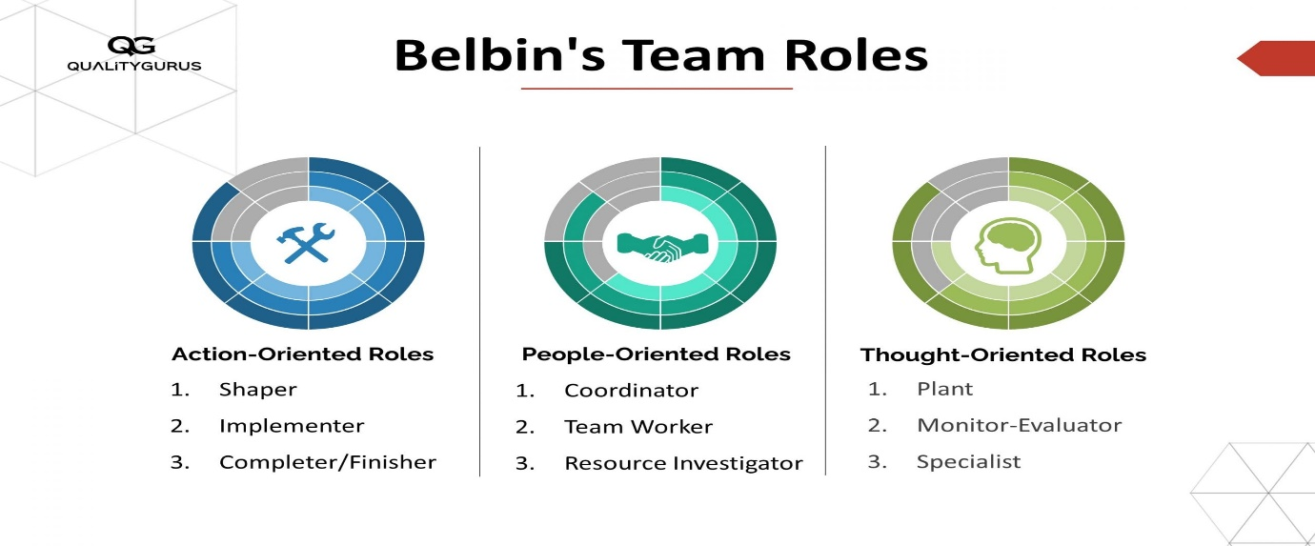
Figure 2: Belbin's team roles

Analysing team roles according to Belbin's Team Roles concept.

- Leader/President - Coordinator and Shaper.

Coordinator: The coordinator focuses on the team's objectives, delegates tasks effectively, and ensures that all team members contribute. They are confident, mature, and good at clarifying goals.

Shaper: The Shaper drives the team forward and challenges them to improve. They are dynamic, thrive on pressure and have the courage to overcome obstacles.

Effectiveness: As a Coordinator and Shaper, set clear goals, delegate tasks, and maintain momentum. Effective coordination and drive help keep the team focused and motivated. Ensure balance assertiveness with support to avoid potential conflicts.

- Content Developer - Plant and Specialist.

Plant: The Plant is creative and solves complex problems. They generate ideas and provide innovative solutions.

Specialist: The Specialist offers in-depth knowledge and skills in a particular area. They are dedicated and focus on their expertise.

Effectiveness: As a Plant and Specialist, the Content Developer brings creativity and deep knowledge to the training materials. This ensures the content is both engaging and accurate. Encourage collaboration to integrate their ideas effectively with the overall program.

- Logistics and Technical Support Manager - Implementer and Completer or Finisher.

Implementer: The Implementer is practical and efficient. They turn ideas into action and organize work systematically.

Completer / Finisher: The Completer Finisher pays attention to detail and ensures that tasks are completed to a high standard. They are meticulous and quality-oriented.

Effectiveness: As an Implementer and Completer Finisher, the Logistics and Technical Support Manager ensures smooth operations and high standards. Their efficiency and attention to detail are crucial for preventing disruptions and ensuring everything runs as planned.

- Marketing and Communications Coordinator - Resource Investigator and Team worker.

Resource Investigator: The Resource Investigator is outgoing and enthusiastic. They explore opportunities and develop contacts.

Team worker: The Team worker is cooperative and diplomatic. They help the team work together effectively and support team cohesion.

Effectiveness: As a Resource Investigator and Team worker, the Marketing and Communications Coordinator excels in promoting the program and maintaining team harmony. Their ability to network and foster collaboration is key to attracting participants and ensuring clear communication.

- Feedback and Evaluation Coordinator - Monitor - Evaluator and Reflector.

Monitor Evaluator: The Monitor Evaluator is logical and impartial. They analyse options and make balanced decisions.

Reflector: The Reflector is thoughtful and observant. They consider different perspectives and provide valuable insights.

Effectiveness: As a Monitor Evaluator and Reflector, the Feedback and Evaluation Coordinator provides objective analysis and thoughtful feedback. This role is vital for continuous improvement and ensuring the training program meets participants' needs.

Analysing team dynamics according to Belbin's Team Roles framework provides a structured approach to understanding the specific roles of group members and their impact on achieving shared goals.

Analyse roles played by group members and their effectiveness in achieving shared goals using Belbin’s team roles.

In our digital literacy training program, effective team dynamics were crucial in ensuring the success of the event. Here’s a scenario illustrating how each team member played their role according to Belbin’s Team Roles framework.

1.Action/Task-Oriented Roles.

Aasath Mohamed Asrif - Logistics and Technical Support Manager (Implementer and Completer Finisher)
During the event, Asrif ensured that all the necessary equipment was set up and functioning correctly. When there was a technical glitch with the presentation equipment, he quickly resolved the issue, preventing any disruption to the training schedule. His meticulous planning and execution ensured that the event ran smoothly and on time.

2.People-Oriented Roles.

Mohamed Sakkaf Mohamed Jaasir - Marketing and Communications Coordinator (Resource Investigator and Team worker).
Mohamed Jaasir developed a comprehensive marketing plan that included social media campaigns, email newsletters, and community outreach. He established contacts with local organizations to promote the event and secured a partnership that increased our participant numbers. His friendly and approachable demeanour ensured smooth communication and coordination among all team members and stakeholders.

3.Thought-Oriented Roles

Ahamadhu Mohamed Imran - Content Developer (Plant and Specialist).
Mohamed Imran designed engaging and interactive training modules that kept participants interested and involved. His creative approach included using real-life examples and practical exercises, making the content relatable and easy to understand. He also conducted thorough research to ensure the accuracy and relevance of the materials.

Mohamed Rafeek Ahamed Ahnaf - Feedback and Evaluation Coordinator (Monitor Evaluator and Reflector)
After each training session, Ahnaf collected feedback from participants through surveys and focus groups. He analysed the data to identify areas of improvement and discussed these findings with the team. His objective evaluation helped us refine the content and delivery methods, ensuring that the program continuously evolved to meet participants' needs.

Mohammed Naseer Sihanas - President (Shaper and Coordinator)
As a president myself I led regular team meetings to review progress and address any challenges. When the team faced obstacles, I remained calm and provided clear guidance to find solutions. My leadership ensured that all team members were aligned with the program's goals and worked together cohesively. I also made sure that the team met deadlines and delivered a high-quality training program.

In our digital literacy training program, each team member played a crucial role aligned with Belbin’s Team Roles framework. Asrif’s practical logistics management, Mohamed Jaasir’s effective communication and promotion, Imran’s creative content development, Mohamed Ahnaf’s insightful feedback analysis, and Sihanas’s strong leadership all contributed to the program’s success. By leveraging each member's strengths and fostering effective team dynamics, we were able to deliver a successful and impactful training event.

3.3 Critically evaluate your own role and contribution to the team.

According to James Cash Penny, "the best teamwork comes from men who are working independently towards one goal in unison." As the President of the team for our digital literacy training program, I had a vital role in guiding and coordinating the event. My responsibilities included setting clear objectives, delegating tasks, maintaining team motivation, and ensuring that the program was executed efficiently and effectively.

My Role and Responsibilities
As the President, my primary responsibility was to provide direction and motivation for the team. I had to ensure that everyone stayed focused on our common goal and worked together harmoniously. My tasks included:

- Setting Clear Objectives: Defining the goals of the training program and ensuring that all team members understood and aligned with these objectives
- Delegating Tasks: Assigning specific responsibilities to each team member based on their strengths and expertise.
- Maintaining Motivation: Keeping the team motivated and on track, especially during challenging times.
- Problem Solving: Addressing any issues that arose during the planning and execution phases and finding effective solutions.
- Communication: Ensuring open and transparent communication within the team and with external stakeholders.

My Contribution to the Shared Goal
My contribution as the leader was crucial in several key areas.

- Leadership and Coordination: By setting clear goals and ensuring that tasks were delegated appropriately, I helped maintain a sense of direction and purpose within the team. My leadership ensured that all team members were aligned and working towards our shared goal.
- Motivation and Support: I worked hard to keep the team motivated and focused, providing support and encouragement whenever needed. My ability to inspire and motivate the team was essential in maintaining high levels of engagement and productivity.
- Problem Solving and Decision Making: Throughout the event planning and execution, I encountered various challenges that required quick and effective decision-making. By addressing these issues promptly and efficiently, I ensured that the program stayed on track and met its objectives.
- Communication and Collaboration: I facilitated open and transparent communication within the team, ensuring that everyone was informed and involved in the decision-making process. This fostered a collaborative environment where all team members felt valued and heard.

Areas for Improvement
Despite the successful execution of the event, I recognize that there are areas where I can improve:

- Enhanced Communication: While I maintained open communication within the team, I realize that better communication with our audience and external stakeholders could have further improved the program's impact. Developing stronger communication skills will help me connect more effectively with all involved parties.

- Improving Motivational Skills: As a leader, one of my roles is to inspire and motivate the team. I believe that enhancing my motivational skills will help me better encourage and uplift my team members, leading to higher levels of engagement and productivity.

- Delegation and Trust: While I was effective in delegating tasks, I could improve in trusting my team members to execute their responsibilities without excessive oversight. Empowering the team more can lead to increased autonomy and confidence among team members.

Reflection on My Role
Being the President of the team was a challenging yet rewarding experience. It required a balance of strategic planning, effective communication, and motivational leadership. I am proud of the role I played in guiding the team towards our common goal and the success we achieved.

However, I acknowledge that continuous improvement is essential, and I am committed to developing my skills further to become a better leader.

In conclusion, my role as the leader was integral to the success of our digital literacy training program. By providing direction, maintaining motivation, solving problems, and fostering communication, I was able to contribute significantly to our shared goal. Moving forward, I will focus on enhancing my communication and motivational skills to become an even more effective leader.

Task 4

4.1 Consider your personal and/or career goals and identify your CPD needs. Then, outline a development plan to achieve these goals.

CPD, or Continuing Professional Development, is the ongoing process of learning and growing in your career. It's about enhancing your skills and knowledge to excel in your current role and prepare for future opportunities. (John Schostak, 2010)

Essentially, CPD involves setting goals and tracking your progress towards achieving them.

Using SWOT analysis to find own weaknesses and threats.

Strength | - Strategic Planning  - Problem-Solving Abilities  - Leadership Skills
Weakness | - Communication skills  - Cyber security  - Programming in Python
Opportunities | - Professional Development Courses  - Mentorship Programs  - Industry Certifications
Threats | - Competition  - Rapid Technological Changes  - Resource Constraints
Table 8: self SWOT analysis

From this analysis, I selected four needs to improve in future. I created a CPD (Continuing Professional Development) plan below to improve them.

Personal CPD (Continuing Professional Development) plan

What do I want / needed to learn | What will I do to achieve this | What resource or support do I need | What will my success criteria will be | Target dates for review and completion
Communication skills | Enrol in a public speaking course | Course enrolment fee | Clear and effective communication | - Review monthly  - Completion 2024/12/1
Cybersecurity Fundamentals | Take an online cybersecurity course | Access to cybersecurity tools and software | Implementation of basic cybersecurity measures | - Review weekly  - Completion 2024/10/15
Python language | Work on Python projects and practice coding regularly | An Expert python mentor | Development of Python-based applications | - Review monthly  - Completion 2025/7/1
AI and Machine Learning | Participate in AI/ML workshops and seminars | AI/ML development tools and software | Successful implementation of AI/ML projects | - Review every 2 month  - Completion 2026/1/1
Table 9: Own CPD plan

4.3 Review different motivational theories and the impact they can have on performance in the workplace and justify the role of CPD and development planning in building motivation.

Review of different motivational theories and the impact they can have on performance in the workplace.

1. Maslow's Hierarchy of Needs.

Theory Overview:
Maslow proposed a pyramid-like structure of human needs, with basic survival needs at the bottom and more complex, intellectual needs at the top. He believed that people must satisfy their fundamental needs before they can focus on higher-level ones. As individuals progress upward, achieving these needs becomes increasingly challenging due to personal and external obstacles. Unlike basic survival needs, the upper levels are more psychological and long-term in nature. (mcleaod, 2024)
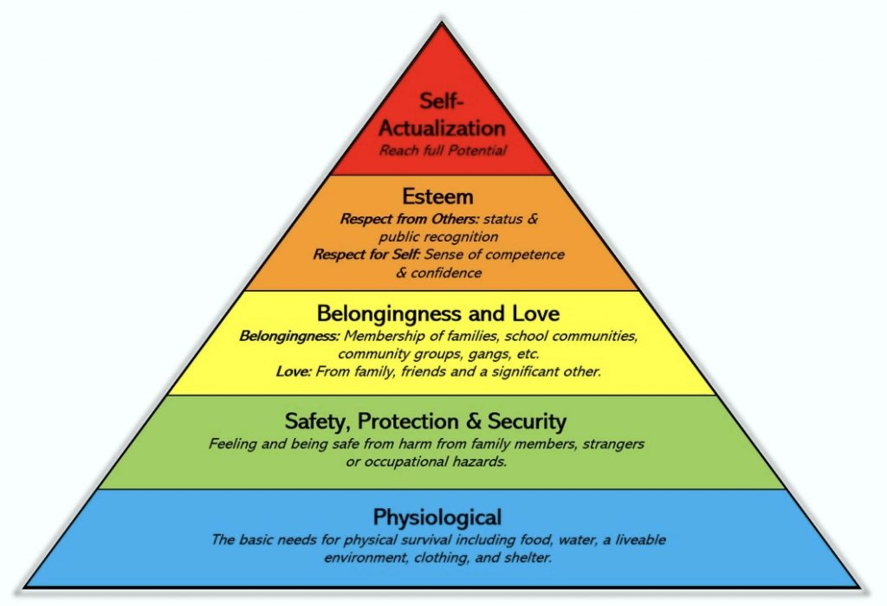
Figure 3: Maslow’s Hierarchy of Needs
1. Physiological needs
Humans are fundamentally driven by the need for survival. Our most basic physical requirements take priority, and until these are met, other desires are secondary. Once our physiological needs, such as food, water, and shelter, are satisfied, we begin to focus on the next level of human need: security and safety. (mcleaod, 2024)

2. Safety needs
Once our basic survival needs are met, we seek security and stability. This includes financial security, protection from harm, and a sense of safety within our environment. These needs are often fulfilled through family, community, and societal structures. Only after these foundational needs are satisfied do we focus on fulfilling our social needs, which involve a sense of belonging and connection with others. (mcleaod, 2024)

3. Love and belongingness needs
Humans have a deep-rooted desire for social connection. This need for belonging encompasses friendship, intimacy, trust, and love. The craving for acceptance and affection is particularly pronounced during childhood, often taking precedence over safety, as seen in cases of children enduring abusive environments. (mcleaod, 2024)

4. Esteem needs
People have a fundamental need for both self-respect and the respect of others. This desire for recognition and appreciation drives many human behaviors, such as career choices and hobbies. While self-esteem is crucial for personal growth, the need for external validation is often more pronounced in younger individuals. An imbalance in this area can lead to feelings of inferiority. (mcleaod, 2024)

5. Self-actualization needs
Self-actualization is the pinnacle of human potential, according to Maslow. It's the drive to become the best version of oneself. This can manifest in various ways, from artistic expression to exceptional parenting. While achieving a constant state of self-actualization is rare, everyone experiences fleeting moments of this fulfilment, often linked to significant life events. (mcleaod, 2024)

Impact on Workplace Performance

1.Physiological Needs: Ensuring employees have a comfortable working environment, fair wages, and adequate breaks.

2.Safety Needs: Providing job security, safe working conditions, and benefits like health insurance.

3.Social Needs: Encouraging team collaboration, social events, and a friendly work atmosphere.

4.Esteem Needs: Recognizing achievements, offering opportunities for advancement, and giving responsibilities.
5.Self-Actualization Needs: Providing opportunities for personal growth, creativity, and challenging tasks.

2. Herzberg's Two-Factor Theory.

Theory Overview:
Herzberg's two-factor theory suggests that job satisfaction and dissatisfaction are separate concepts, each influenced by different factors. Factors leading to job satisfaction are related to personal growth and achievement, while those causing dissatisfaction are linked to work conditions and environment. This theory has become a cornerstone in understanding employee motivation and job satisfaction. Essentially, certain factors motivate employees, while others simply prevent dissatisfaction. (Nickerson, 2023)
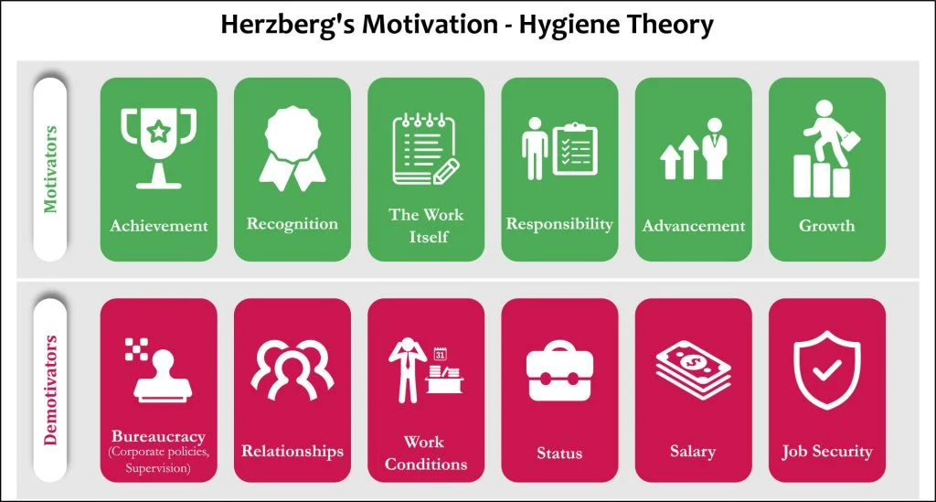
Figure 4: Herzberg's two factor theory

Motivation Factors
- Advancement: Herzberg defined advancement as the upward and positive status or position of someone in a workplace.
Meanwhile, a negative or neutral status at work represents negative advancement. (Alshmemri, 2017)

- The work itself: The content of job tasks can positively or negatively affect employees.
The job’s difficulty and level of engagement can dramatically impact satisfaction or dissatisfaction in the workplace . (Alshmemri, 2017)

- Possibility for growth: Possibilities for growth exist in the same vein as Maslow’s self-actualization; they are opportunities for a person to experience personal growth and promotion in the workplace.
Personal growth can result in professional growth, increased opportunities to develop new skills and techniques, and gaining professional knowledge . (Alshmemri, 2017)

- Responsibility: Responsibility encompasses both the responsibilities held by the individual and the authority granted to the individual in their role.
People gain satisfaction from being given the responsibility and authority to make decisions. Conversely, a mismatch between responsibility and level of authority negatively affects job satisfaction. (Alshmemri, 2017)

- Recognition: When employees receive praise or rewards for reaching goals or producing high-quality work, they receive recognition.
Negative recognition involves criticism or blame for a poorly done job (Alshmemri, 2017)

- Achievement: Positive achievement can involve, for example, completing a difficult task on time, solving a job-related problem, or seeing positive results from one’s work.
Negative achievement includes failure to progress at work or poor job-related decision-making (Alshmemri, 2017).

Hygiene Factors
- Interpersonal relations: Interpersonal relationships involve the personal and working relationships between an employee and his supervisors, subordinates, and peers.
This can manifest in, for example, job-related interactions as well as social discussions in both the work environment and during informal break times. (Alshmemri, 2017)

- Salary: Salary includes wage or salary increases and negative unfulfilled expectations of wage or salary increases . (Alshmemri, 2017)

- Company policies and administration: Company policies and administration include factors such as the extent to which company organization and management policies and guidelines are clear or unclear.
For example, a lack of delegation of authority, vague policies and procedures, and communication may lead to job dissatisfaction . (Alshmemri, 2017)

- Supervision: Supervision involves an employee’s judgments of the competence or incompetence and fairness or unfairness of the supervisor or supervision.
For example, this could include a supervisor’s willingness to delegate responsibility or teach and their knowledge of the job.
Poor leadership and management can decrease job dissatisfaction. (Alshmemri, 2017)

- Working conditions: Finally, working conditions involve the physical surroundings of the job and whether or not they are good or poor.
Factors leading to a good or poor workspace could involve the amount of work, space, ventilation, tools, temperature, and safety. (Alshmemri, 2017)

Impact on Workplace Performance
Hygiene Factors: Ensuring these factors are addressed to prevent dissatisfaction.

Motivators: Focusing on providing challenging work, recognizing achievements, and offering growth opportunities to enhance motivation and performance.

Example:
A company that regularly recognizes employee achievements and offers professional development opportunities will likely see higher motivation and productivity levels.

3.McGregor's Theory X and Theory Y
Theory overview:
Theory X assumes employees are inherently lazy and need strict supervision, while Theory Y assumes employees are self-motivated and thrive on responsibility. (Kurt, 2021)
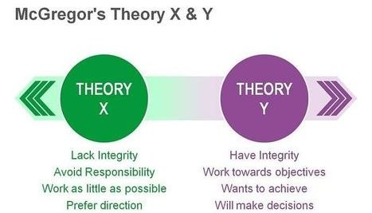
Figure 5: McGregor's theory x, y

The first part of McGregor’s theory is Theory X. Managers have many assumptions about their employees in Theory X:
- Workers dislike their jobs and they are inherently lazy.
- Workers have little motivation and prefer direction from their superiors.
- Workers need consistent rewards and punishments to ensure their task is completed.
- Workers do not have a desire to grow or achieve personal or professional goals. (Kurt, 2021)
- The next part of McGregor’s theory is Theory Y. Managers also have assumptions about their employees in Theory Y:
- Workers are willing to accept challenges and are proud of the work that they do.
- Workers do not need to be micromanaged; they are self-directed.
- Workers are eager to participate in decision-making.
- Workers are happy to contribute and feel internally satisfied. (Kurt, 2021)

Impact on Workplace Performance:
Theory X: May lead to a restrictive and controlled environment, potentially stifling creativity and motivation.

Theory Y: Encourages a participative management style, fostering a positive work environment and higher motivation and productivity.

Example:
Adopting Theory Y by empowering employees, involving them in decision-making, and providing opportunities for self-direction can lead to higher engagement and performance.

Impact and effectiveness of CPD and Development Planning in Building Motivation

Continuous Professional Development (CPD)
Definition and Purpose:
CPD involves ongoing learning and development to enhance skills, knowledge, and competencies. It is a proactive approach to professional growth, ensuring individuals remain competent and effective in their roles.

Impact on Motivation:
- Skill Enhancement: By improving skills, employees feel more competent and confident in their roles, leading to higher job satisfaction and motivation.
- Career Advancement: CPD provides opportunities for career progression, which can be a significant motivator for employees.
- Personal Growth: Engaging in CPD activities fulfils self-actualization needs, fostering a sense of accomplishment and personal development.
- Adaptability: CPD ensures employees stay updated with industry trends and technologies, increasing their value to the organization and their motivation to contribute.

Development Planning
Definition and Purpose:
Development planning involves creating structured plans for an individual's growth and career progression. It typically includes setting goals, identifying development needs, and outlining steps to achieve those goals.

Impact on Motivation:
- Goal Setting: Clearly defined goals provide direction and purpose, enhancing focus and motivation.
- Progress Tracking: Regular reviews and adjustments to development plans keep employees engaged and motivated by recognizing their progress and achievements.
- Alignment with Organizational Goals: Development planning aligns individual aspirations with organizational objectives, fostering a sense of contribution and commitment.

- Support and Resources: Providing the necessary resources and support for development plans ensures employees feel valued and supported, boosting their motivation.

Justification of CPD and Development Planning in Building Motivation

- Employee Engagement: CPD and development planning engage employees by involving them in their growth and career paths, leading to higher job satisfaction and motivation.
- Retention: Organizations that invest in CPD and development planning are likely to retain top talent, as employees feel valued and see clear opportunities for advancement.
- Performance Improvement: Continuous learning and development lead to skill enhancement, directly impacting job performance and productivity.
- Adaptability and Innovation: Employees who engage in CPD are more adaptable to change and likely to contribute innovative ideas, driving organizational success.
- Organizational Growth: Motivated employees who continuously develop their skills contribute to the overall growth and competitiveness of the organization.

Understanding and applying motivational theories helps in creating strategies that enhance workplace performance. CPD and development planning play crucial roles in building and sustaining motivation by providing structured growth opportunities, aligning individual and organizational goals, and ensuring employees feel valued and supported.

4.4 Discuss the use of CPD within organizations and what evidence would be required to measure the effectiveness of CPD in helping the target audience achieve their goals while using their time and resources effectively.

Continuing Professional Development (CPD) is a structured approach to lifelong learning that professionals engage in to enhance their skills and knowledge throughout their careers. Within organizations, CPD serves as a vital tool for employee development, helping to improve performance, increase job satisfaction, and adapt to changing industry demands.

Use of CPD in Organizations

- Employee Engagement and Retention:
CPD fosters a supportive work environment, leading to higher employee motivation and retention. When employees feel that their professional growth is valued, they are more likely to remain committed to the organization. (Team, 2022)

- Cost-Effectiveness:
Organizations can implement CPD initiatives without incurring substantial costs. By utilizing a mix of structured and unstructured learning opportunities—such as online courses, workshops, and self-directed study—companies can provide valuable training that fits within budget constraints. (Team, 2022)

- Skill Enhancement:
CPD enables employees to keep their skills current, which is essential in fast-evolving industries. This ongoing learning process helps organizations maintain a competitive edge by ensuring that their workforce is knowledgeable about the latest trends and technologies (Jennifer Pienaar, 2020)

- Flexibility and Accessibility:
The rise of online learning platforms has made CPD more accessible. Employees can engage in learning at their convenience, which minimizes disruptions to their work schedules while maximizing learning opportunities. (Jennifer Pienaar, 2020)

Measuring the Effectiveness of CPD

1. Comprehensive Evaluation Frameworks
To measure CPD effectiveness, organizations should adopt comprehensive evaluation frameworks, such as:

Kirkpatrick Model: 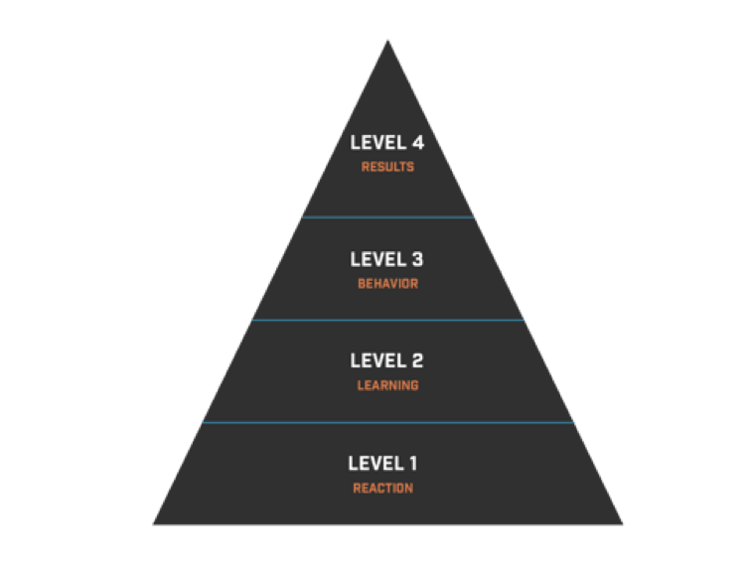
Figure 6: Kirkpatrick model
“The Kirkpatrick principles are essential to maximizing the transfer of learning to behaviour and subsequent organizational results as well as to demonstrate the value of training to the organization; unquestionably critical for any world-class institution!” (Dr. John Plifka)

This four-level model evaluates training effectiveness through,

- Reaction: Assessing how participants feel about the training.

The initial step in evaluating a course is gauging learners' immediate reactions. This involves determining if they found the course engaging, enjoyable, and relevant to their work. To gather this feedback, L&D teams commonly use surveys and simple rating forms. These methods can be applied to both in-person and online training. For digital learning, online survey tools are often employed. This initial feedback is also referred to as a post-training evaluation. (Suresh Kumar, 2022)

- Learning: Measuring knowledge or skills gained.

The second stage of evaluating training focuses on measuring what learners have acquired. Assessments are typically used for this purpose. There are two main types: formative and summative. Formative assessments, such as knowledge checks or practice questions, occur during training. Summative assessments, conducted after training, determine if learners grasped the material. These often include final exams or projects with specific passing scores. Additionally, interviews, group discussions, and role-playing can assess learners' understanding and application of knowledge. (Suresh Kumar, 2022)

- Behaviour: Observing changes in workplace behaviour post-training.

The third level of evaluation focuses on measuring changes in behaviour after training. This is more challenging to assess, but methods exist. Regular feedback sessions, peer reviews, and observing if learners apply new skills on the job can help measure behavioural changes. (Suresh Kumar, 2022)

- Results: Evaluating the impact on organizational outcomes, such as productivity and profitability.

The final level of evaluation determines the impact of training on business outcomes. To measure this, L&D and business teams must establish a clear framework linking performance indicators and learning objectives. However, it's important to recognize that business success often depends on multiple factors, not solely training. Consequently, attributing specific outcomes to training requires careful analysis. While training in areas like compliance or safety can be directly linked to metrics like reduced errors or accidents, most training initiatives require close collaboration between L&D and business units to establish meaningful performance measures. (Suresh Kumar, 2022)

Phillips ROI Model: This model extends the Kirkpatrick framework by calculating the return on investment (ROI) for CPD initiatives, providing a financial perspective on training effectiveness.

- Quantitative and Qualitative Metrics
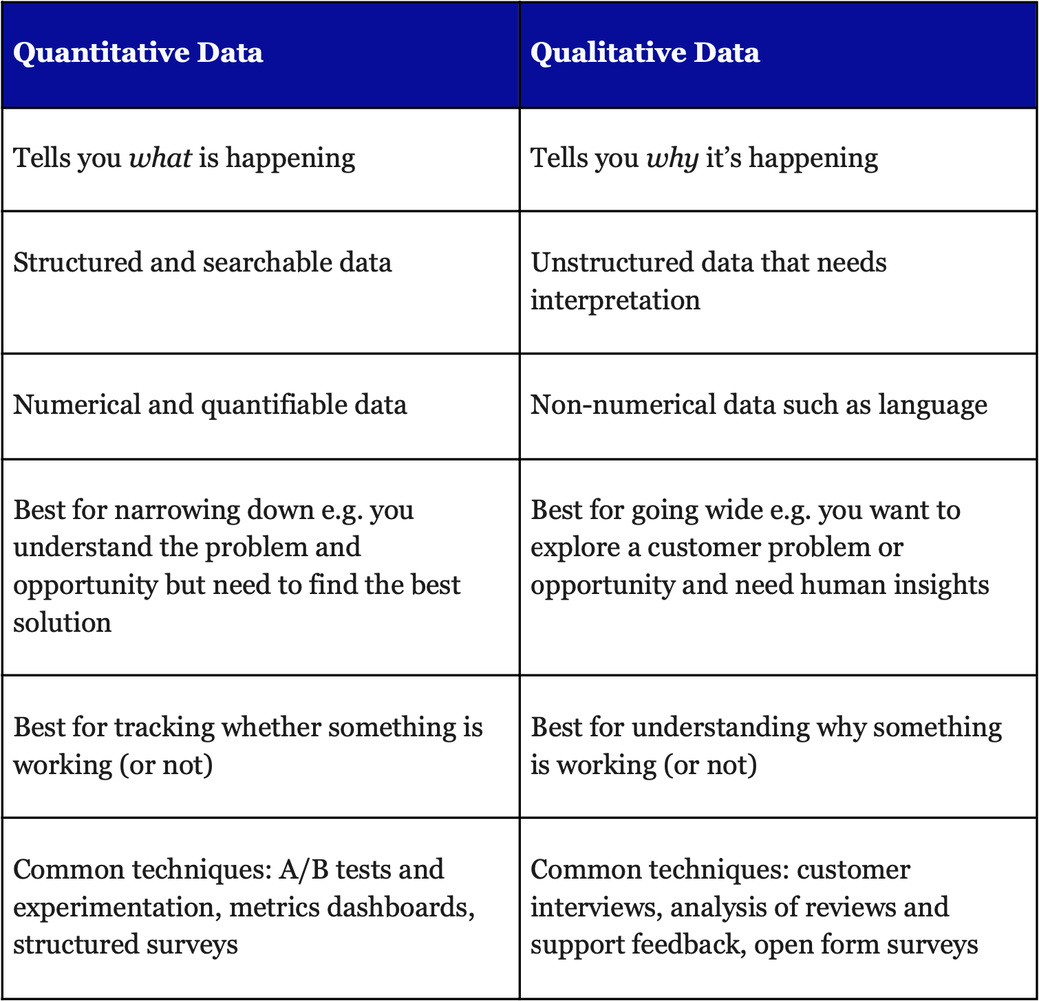
Figure 7: comparison of quantitative and qualitative metrics
Organizations should employ a mix of quantitative and qualitative metrics to gauge CPD effectiveness:

Quantitative Metrics:
Quantitative metrics rely on numerical data collected through structured methods like surveys or experiments. These numbers measure specific aspects such as sales, customer loyalty, or production output. They offer clear and concrete information for analysis and comparison. For example, in business, key performance indicators like profit, market dominance, or customer satisfaction are measured using quantitative metrics. These figures help companies monitor progress and pinpoint areas for improvement. (Brereton, 2023)
Performance Indicators: KPIs related to productivity, quality, and efficiency can be tracked before and after CPD participation.

- Retention Rates: Analysing turnover rates can provide insights into employee satisfaction and engagement levels.

Qualitative Metrics:
Qualitative metrics explore the subjective side of data, focusing on understanding the reasons behind actions rather than just the numbers. These insights come from exploring people's thoughts, feelings, and experiences. By using methods like interviews and open-ended questions, businesses can gather rich details about customer experiences or employee perspectives. (Brereton, 2023)

For example, understanding why customers are satisfied helps companies identify strengths and areas for improvement.

- Employee Surveys and Interviews: Gathering feedback on CPD experiences can reveal insights into its perceived value and areas for improvement.
- Focus Groups: Engaging small groups of employees in discussions about CPD can yield in-depth qualitative data on its impact.

- Longitudinal Studies
Longitudinal studies track the same individuals over time to identify changes. This research method observes and records various factors without interfering. It's a way to study how things develop or evolve. (Thomas, 2020)

Conducting longitudinal studies can provide valuable insights into the long-term impact of CPD on employee performance and organizational success. By tracking participants over time, organizations can assess the sustainability of learning outcomes and their contribution to career progression.

Advantages of longitudinal studies

- By following participants over time, prospective studies avoid the problem of relying on people's memories to recall past events. (Thomas, 2020)

- By repeatedly studying the same people, researchers can pinpoint changes over time without confusing them with differences between individuals. (Thomas, 2020)

- Longitudinal studies provide a real-time view of participants, allowing researchers to observe events unfold in their natural order. This helps uncover cause-and-effect relationships more accurately. (Thomas, 2020)

disadvantages of longitudinal studies

- Uncovering insights from longitudinal studies can be a time-consuming process due to the extended observation period. (Thomas, 2020)

- A common challenge in longitudinal studies is participant dropout, which can compromise the accuracy of the results. (Thomas, 2020)

CPD is a critical component of professional development within organizations, offering numerous benefits while requiring careful planning and evaluation to ensure its effectiveness. By implementing robust measurement strategies, organizations can optimize their CPD initiatives to align with their goals and the developmental needs of their workforce.

Conclusion

In conclusion, the journey of planning and executing the IT training program for BITS provided a profound learning experience that encompassed multiple aspects of project management and team collaboration. The success of the training program was a testament to the meticulous planning, clear communication, and effective problem-solving strategies implemented throughout the process. The collaborative efforts of the team members, each bringing unique skills and perspectives, were pivotal in achieving the program's objectives and ensuring a seamless delivery. This assignment reinforced the critical importance of team dynamics, demonstrating how collective effort and shared goals can lead to the successful realization of a project.

Moreover, the experience underscored the essential role of Continuing Professional Development (CPD) in staying current with technological trends and enhancing professional capabilities. The insights gained from participant feedback will be invaluable in refining future training initiatives, fostering a culture of continuous improvement, and ensuring that the IT Society remains a dynamic and responsive entity within the academic community. This assignment has not only enhanced my leadership and organizational abilities but also provided a deeper understanding of the intricacies involved in managing a successful training event. As we move forward, the lessons learned from this experience will serve as a foundation for future endeavors, promoting a sustained commitment to excellence and professional growth.

References
Alshmemri, M. S.-A. L. &. M. P., 2017. Herzberg’s two-factor theory. Life Science Journal, Volume 14(5), pp. 12-16.
Anon., 2022. riseup. [Online]
Available at: https://blog.riseup.ai/en/improve-interpersonal-skills
[Accessed 24 6 2024].
ashenden, p., 2020. lifesize. [Online]
Available at: https://www.lifesize.com/blog/speaking-without-words/#:~:text=Changes%20in%20vocal%20tone%20during,understanding%20of%20the%20person%20speaking.
[Accessed 13 7 2024].
Brereton, J., 2023. launch notes. [Online]
Available at: https://www.launchnotes.com/blog/qualitative-vs-quantitative-metrics-a-comprehensive-comparison
[Accessed 24 7 2024].
herrity, j., 2024. www.indeed.com. [Online]
Available at: https://www.indeed.com/career-advice/resumes-cover-letters/interpersonal-skills
[Accessed 20 7 2024].
Jennifer Pienaar, W. K., 2020. research gate. [Online]
Available at: https://www.researchgate.net/publication/342638733_Continuing_professional_development_CPD_a_necessary_component_in_the_workplace_or_not
[Accessed 24 7 2024].
John Schostak, J. H. M. D. J. S., 2010. research gate. [Online]
Available at: https://www.researchgate.net/publication/45284341_Effectiveness_of_Continuing_Professional_Development'_project_A_summary_of_findings
[Accessed 17 6 2024].
Kurt, D. S., 2021. education library. [Online]
Available at: https://educationlibrary.org/theory-x-and-theory-y-douglas-mcgregor/
[Accessed 26 7 2024].
mcleaod, s., 2024. simply phsycology. [Online]
Available at: https://www.simplypsychology.org/maslow.html
[Accessed 25 7 2024].
Myers, S. P., 2013. team technology. [Online]
Available at: https://www.teamtechnology.co.uk/team/dynamics/definition/
[Accessed 21 6 2024].
Nickerson, h., 2023. simply phsycology. [Online]
Available at: https://www.simplypsychology.org/herzbergs-two-factor-theory.html
[Accessed 25 7 2024].
Roberts, S., 2023. theknowledgeacademy. [Online]
Available at: Sienna Roberts
[Accessed 20 6 2024].
Suresh Kumar, D., 2022. elearning industry. [Online]
Available at: Suresh Kumar DN
[Accessed 20 7 2024].
Team, C. N., 2022. CPD. [Online]
Available at: https://cpduk.co.uk/news/the-benefits-of-cpd-for-small-businesses
[Accessed 21 7 2024].
Thomashttps://www.scribbr.com/methodology/longitudinal-study/, L., 2020. scribbr. [Online]
Available at: https://www.scribbr.com/methodology/longitudinal-study/
[Accessed 25 7 2024].
Thomas, L., 2020. scribbr. [Online]
Available at: https://www.scribbr.com/methodology/longitudinal-study/
[Accessed 25 7 2024].
Tripp Driskell, E. S. J. E. D., 2018. research gate. [Online]
Available at: https://www.researchgate.net/publication/325352426_Foundations_of_teamwork_and_collaboration
[Accessed 2 6 2024].

